

Click here



Let’s trace and learn

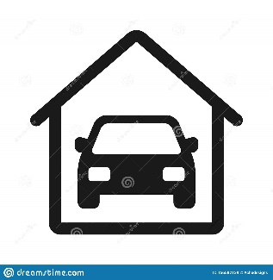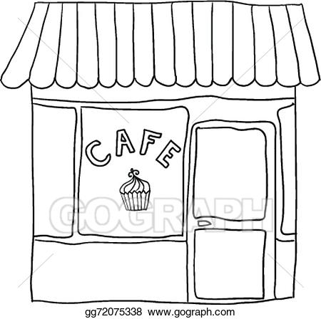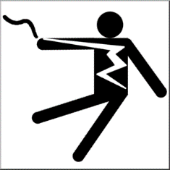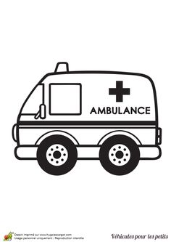

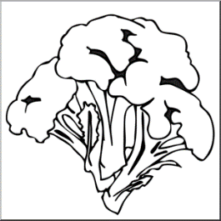

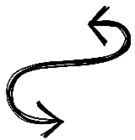D:\yedekler\masaüstü\worksheet helper\Super Sketchy Doodle Pack\arrow2.pngD:\yedekler\masaüstü\worksheet helper\Super Sketchy Doodle Pack\arrow2.pngD:\yedekler\masaüstü\worksheet helper\Super Sketchy Doodle Pack\arrow2.pngD:\yedekler\masaüstü\worksheet helper\Super Sketchy Doodle Pack\arrow2.pngD:\yedekler\masaüstü\worksheet helper\Super Sketchy Doodle Pack\arrow2.pngD:\yedekler\masaüstü\worksheet helper\Super Sketchy Doodle Pack\arrow2.png

Ambulance Broccoli Cafeteria Doctor Electric Football Garage

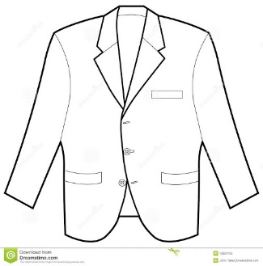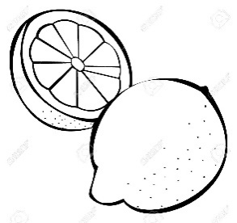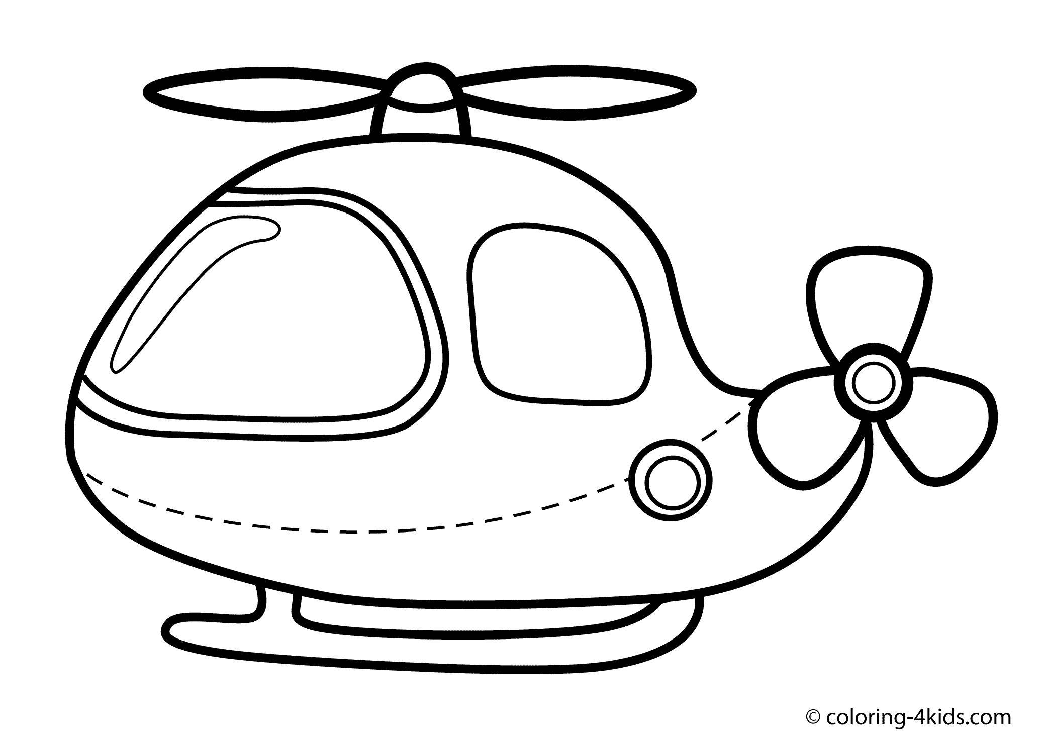

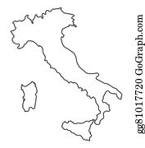

D:\yedekler\masaüstü\worksheet helper\Super Sketchy Doodle Pack\arrow2.pngD:\yedekler\masaüstü\worksheet helper\Super Sketchy Doodle Pack\arrow2.pngD:\yedekler\masaüstü\worksheet helper\Super Sketchy Doodle Pack\arrow2.pngD:\yedekler\masaüstü\worksheet helper\Super Sketchy Doodle Pack\arrow2.pngD:\yedekler\masaüstü\worksheet helper\Super Sketchy Doodle Pack\arrow2.png

D:\yedekler\masaüstü\worksheet helper\Super Sketchy Doodle Pack\arrow2.png

Helicopter Italy Jacket Kimono Lemon Music Negative



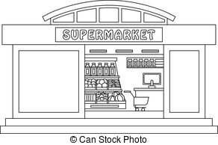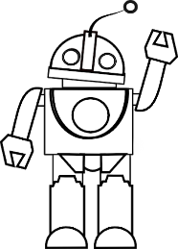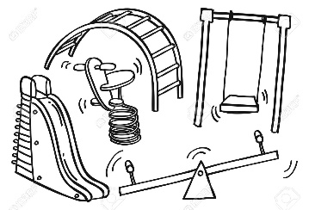



D:\yedekler\masaüstü\worksheet helper\Super Sketchy Doodle Pack\arrow2.png

D:\yedekler\masaüstü\worksheet helper\Super Sketchy Doodle Pack\arrow2.pngD:\yedekler\masaüstü\worksheet helper\Super Sketchy Doodle Pack\arrow2.pngD:\yedekler\masaüstü\worksheet helper\Super Sketchy Doodle Pack\arrow2.pngD:\yedekler\masaüstü\worksheet helper\Super Sketchy Doodle Pack\arrow2.png

Oval Park Quiz Robot Supermarket Telephone

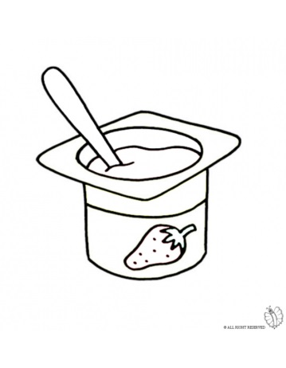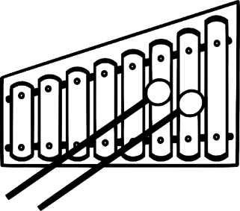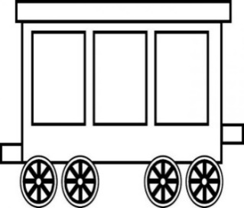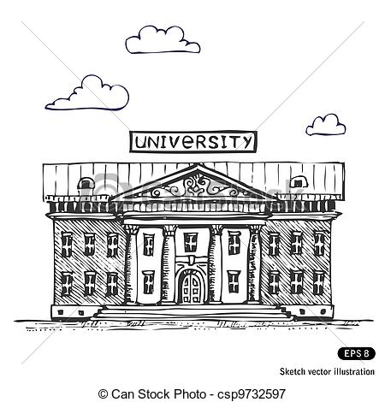

D:\yedekler\masaüstü\worksheet helper\Super Sketchy Doodle Pack\arrow2.pngD:\yedekler\masaüstü\worksheet helper\Super Sketchy Doodle Pack\arrow2.png

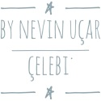D:\yedekler\masaüstü\worksheet helper\Super Sketchy Doodle Pack\arrow2.png

www.newinkle.weebly.com

D:\yedekler\masaüstü\worksheet helper\Super Sketchy Doodle Pack\arrow2.pngD:\yedekler\masaüstü\worksheet helper\Super Sketchy Doodle Pack\arrow2.png

University Veterinarian Wagon Xylophone Yoghur Zebra



Click here



Let’s Listen and sing the song. Write the first letters.





D:\yedekler\masaüstü\worksheet helper\Super Sketchy Doodle Pack\arrow2.pngD:\yedekler\masaüstü\worksheet helper\Super Sketchy Doodle Pack\arrow2.pngD:\yedekler\masaüstü\worksheet helper\Super Sketchy Doodle Pack\arrow2.pngD:\yedekler\masaüstü\worksheet helper\Super Sketchy Doodle Pack\arrow2.pngD:\yedekler\masaüstü\worksheet helper\Super Sketchy Doodle Pack\arrow2.pngD:\yedekler\masaüstü\worksheet helper\Super Sketchy Doodle Pack\arrow2.png

_mbulance _roccoli _afeteria _octor _lectric _ootball _arage





D:\yedekler\masaüstü\worksheet helper\Super Sketchy Doodle Pack\arrow2.pngD:\yedekler\masaüstü\worksheet helper\Super Sketchy Doodle Pack\arrow2.pngD:\yedekler\masaüstü\worksheet helper\Super Sketchy Doodle Pack\arrow2.pngD:\yedekler\masaüstü\worksheet helper\Super Sketchy Doodle Pack\arrow2.pngD:\yedekler\masaüstü\worksheet helper\Super Sketchy Doodle Pack\arrow2.png

D:\yedekler\masaüstü\worksheet helper\Super Sketchy Doodle Pack\arrow2.png

_elicopter _taly _acket _imono _emon _usic _egative







D:\yedekler\masaüstü\worksheet helper\Super Sketchy Doodle Pack\arrow2.png

D:\yedekler\masaüstü\worksheet helper\Super Sketchy Doodle Pack\arrow2.pngD:\yedekler\masaüstü\worksheet helper\Super Sketchy Doodle Pack\arrow2.pngD:\yedekler\masaüstü\worksheet helper\Super Sketchy Doodle Pack\arrow2.pngD:\yedekler\masaüstü\worksheet helper\Super Sketchy Doodle Pack\arrow2.png

_val _ark _uiz _obot _upermarket _elephone



D:\yedekler\masaüstü\worksheet helper\Super Sketchy Doodle Pack\arrow2.pngD:\yedekler\masaüstü\worksheet helper\Super Sketchy Doodle Pack\arrow2.png

D:\yedekler\masaüstü\worksheet helper\Super Sketchy Doodle Pack\arrow2.png

D:\yedekler\masaüstü\worksheet helper\Super Sketchy Doodle Pack\arrow2.pngD:\yedekler\masaüstü\worksheet helper\Super Sketchy Doodle Pack\arrow2.png

_niversity _eterinarian _agon _ylophone _oghurt _ebra

www.newinkle.weebly.com